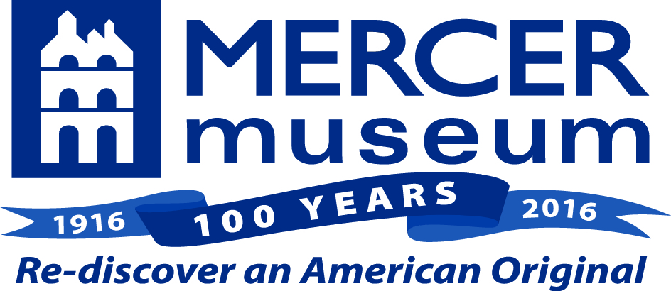
FOR IMMEDIATE RELEASE
Contact:
Gayle Shupack
215-345-0210, ext. 131
gshupack@mercermuseum.org

TWILIGHT TALES AT THE MERCER MUSEUM
Fall Storytelling Series Commemorates Museum’s 100th Anniversary

DOYLESTOWN, PA: (September 7, 2016) – The Mercer Museum continues its 100th anniversary celebration into the fall with a series of storytelling performances called Twilight Tales. In each Twilight Tale, a spoken word artist will perform in the dramatic atmosphere of the Mercer’s original Central Court, in close proximity to the museum’s collection of early tools and artifacts. Each artist will incorporate material inspired by the museum’s collection. The Twilight Tales Performance Series includes “Henry Mercer, the Lenape Stone and First Peoples of the Delaware Valley,” (Sept. 24), “American Tall Tales and Larger-than Life Heroes,” (Oct. 8) and “Tales of Mystery and the Macabre,” (Oct. 27).

The Twilight Tales Series kicks off with “Henry Mercer, the Lenape Stone and First Peoples of the Delaware Valley,” on Saturday, September 24 at 7 p.m. Award-winning storyteller and author, Robin Moore will takes audiences on a journey back 10,000 years to the last great Ice Age, when the first people wandered into what is now Bucks County. Moore will explore how primitive people made fire, clothing and tools from materials in their environment. He will also tell the story of Henry Mercer’s discovery of the “Lenape Stone,” a carved gorget (neck ornament) and Mercer’s attempts to determine whether it was an authentic artifact of Ice Age peoples or an elaborate fake perpetrated by a Bucks County farmer.

Twilight Tales continues on Saturday, October 8 at 7 p.m., with “American Tall Tales and Larger-than Life Heroes.” Poet and storyteller, Michele Belluomini recounts the exploits of legendary heroes including Paul Bunyan, Pecos Bill, Johnny Appleseed, and Sluefoot Sue, illustrating how the tools and implements they used made their extraordinary feats possible. The tales may be funny, poignant, entertaining and larger than life, but they describe the everyday tasks that many pioneers and laborers shared.

Just in time for Halloween, storyteller Bill Wood rounds out the Twilight Tales series by spinning some “Tales of Mystery and the Macabre,” in the shadowy halls of the Mercer Museum on Thursday, October 27 at 7 p.m. Wood’s tales are inspired by some of the museum’s more ghoulish objects including “witch” doctor’s canes, bloodletting instruments, a vampire killing kit and even an inkwell set belonging to Edgar Allan Poe.

The Twilight Tales Performance Series is sponsored by Marv and Dee Ann Woodall of Doylestown. Each performance is followed by refreshments and a chance to meet the performer. The series is appropriate for adults and youth ages 8 and up. Admission is $14 for adults and $12 for youth. Registration for the series can be done by calling 215-348-9461.

About Robin Moore
Robin Moore is an award-winning author, storyteller and educator. Since 1981, he has presented more than 5,000 interpretive history programs to more than a million children and their families. He is the author of more than a dozen books (HarperCollins, Random House, Simon & Schuster) which focus on the rich folklore and history of Pennsylvania. Robin was named National Storyteller of the Year and Author of the Year by the Pennsylvania School Librarians Association. He is an expert in primitive technology and a life-long researcher into primitive life ways which appear in his historically-accurate novels and spoken stories. Robin holds a Bachelor’s Degree in Journalism from Penn State University and a Master’s Degree in Oral Traditions from The Graduate Institute. He currently serves of the faculty of The Oral Traditions Program at TGI in Bethany, CT.

About Michele Belluomini
Michele Belluomini has practiced storytelling at schools, libraries, churches, museums and festivals for the last 15 years. She has performed twice at the National Storytelling Conference, in 2006 and 2012 – a one-hour/one-woman show, Stories to Heal the Earth. She has been a performer for “Philadelphia Tellabration!” on several occasions, most recently in 2012. She has also performed at the Lehigh Valley Story Fusion Festival (2011) and the NJ Storytelling Festival in the Fall of 2011, where she led a workshop for educators. Michele is a University of Pennsylvania Outreach Program presenter through the Commonwealth of Pennsylvania Lecture Program. She is a member of the National Storytelling Network and Patchwork: A Storytelling Guild.

About Bill Wood
Originally a museum educator, Bill Wood loves stories because tales told well can educate, enlighten, inspire, and connect to the personal experience of each individual listener. As a student majoring in comparative religions at Northwestern University, he became fascinated by the similarities found among the parables and myths of so many global cultures and traditions. Having also studied theater, he enjoys creatively portraying and interpreting the experiences of the characters in the stories he tells. He has traveled extensively and traded stories with people on four continents. Both the diversity of the human family, and the commonality of the human experience, provide an endless source of amazement to him. In 1990 Bill turned to storytelling full-time. Since then he has used stories and storytelling to educate, delight and mesmerize both children and adults in schools, libraries, day care centers, theaters, museums, camps, festivals and churches. He estimates that he has exposed more than a half-million children to the power of the story.

About the Mercer Museum
The Mercer Museum, one of Bucks County’s premier tourist attractions, offers visitors a unique window into pre-Industrial America as seen through the implements used in everyday life. The Museum’s collection includes more than 40,000 objects exhibiting the tools of more than 60 different crafts and trades, providing one of the world’s most comprehensive portraits of material culture in America. The Mercer Museum celebrates its 100th anniversary in 2016. On view in the museum’s Martin & Warwick Foundation Galleries from until November 6 is Long May She Wave: A Graphic History of the American Flag. The Mercer Museum is located at Pine Street & Scout Way in Doylestown and is open for self-guided exploration 7 days a week. For more information, call 215-345-0210, or visit: www.mercermuseum.org.
# # #

