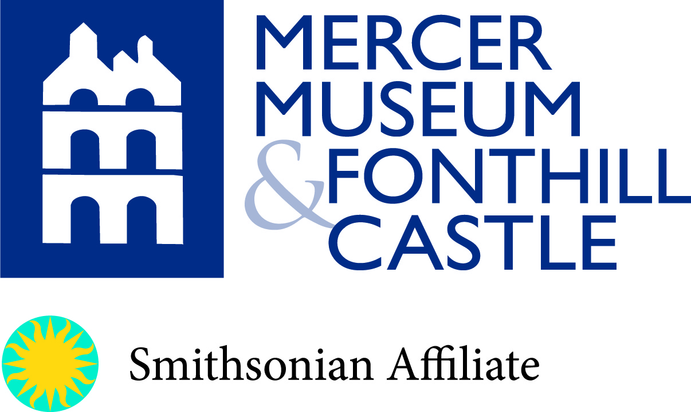

FONTHILL CASTLE CLEAN-UP VOLUNTEER APPLICATION*

*If you are under the age of 18, please complete this form and have your parent(s) or guardian(s) sign for approval. Please return form via…mail: Fonthill Woodlands Volunteer, 84 S. Pine Street, Doylestown, PA 18901;
Or email: info@mercermuseum.org.
Questions or further information, please call 215-345-0210 ext 131

Name:

Address:

Phone Numbers- Home: Cell:

E-mail: Age:

School: Grade:

Parent(s)/ Guardian(s), please list any medical concerns, allergies or information that you would like us to know:

Emergency Contact Information (please list two contacts):
1. Name:
Relationship: Phone:
2. Name:
Relationship: Phone:

Parent(s)/Guardian(s) Name:

Parent(s)/Guardian(s) Signature:
Date:

